iOS SDK Screen Share Extension Integration Guide

1. Enable App Group Feature

Make sure your App Provision File Support App Group Feature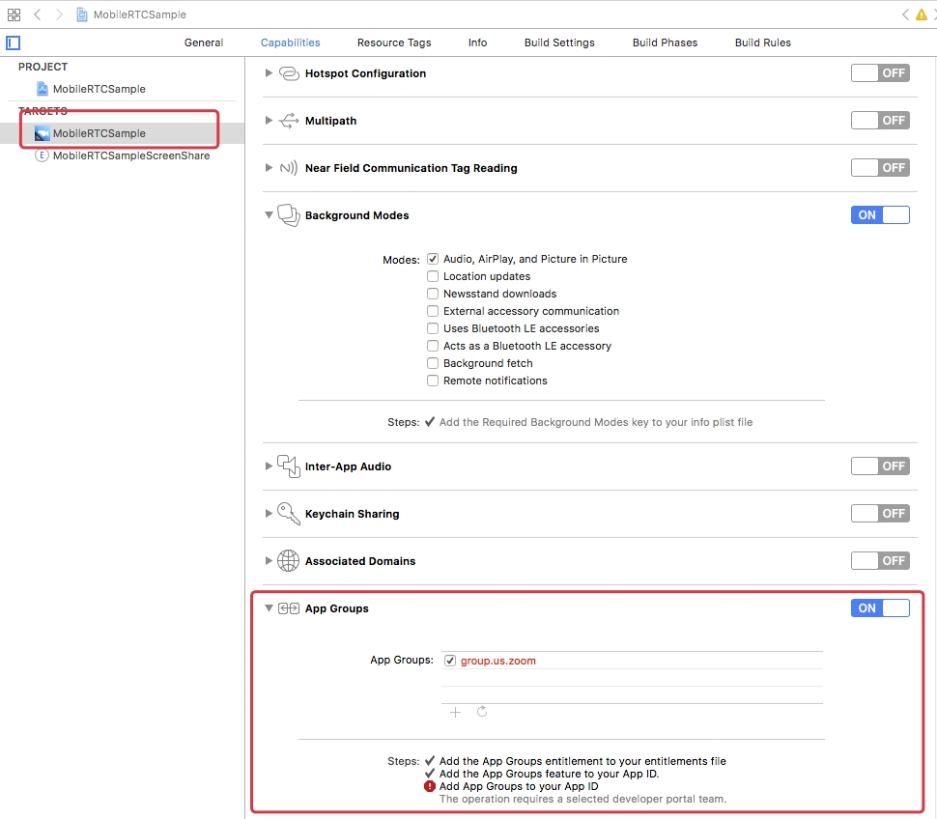

1. Create new Target (Broadcast Upload Extension)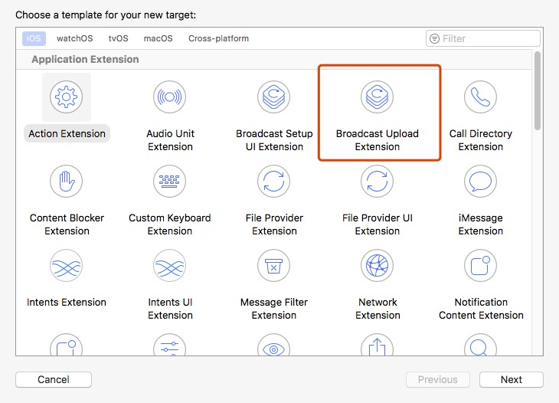
2. Set correct AppGroup Name in AppDelegate

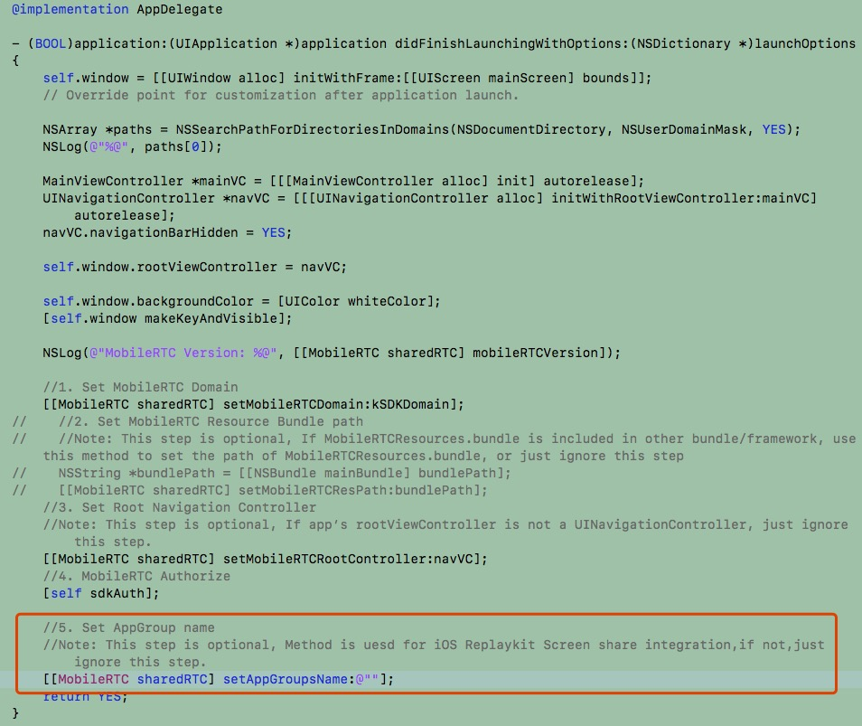

1. Enable AppGroup Feature For New Target (Broadcast Upload Extension)

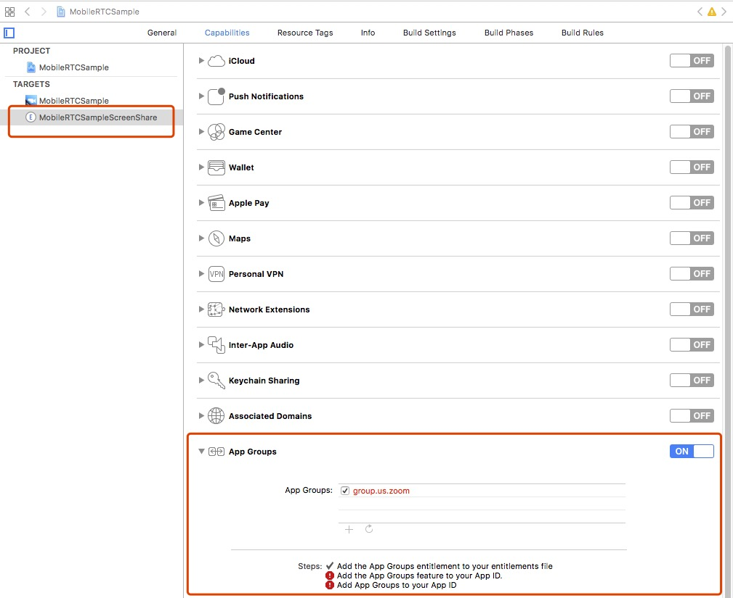

1. Set correct AppGroup Name in SampleHandler.m & Copy Rest Code from SampleHandler.m in SDK Sample.

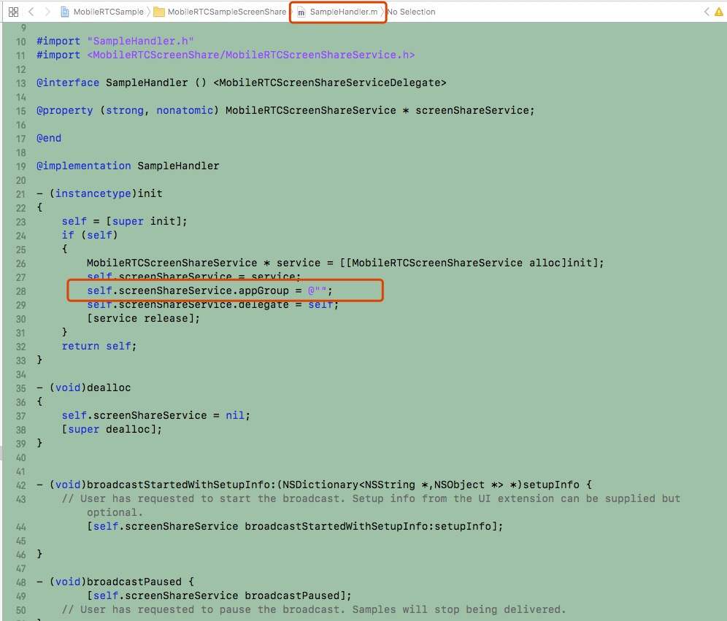

1. Add MobileRTCScreenShare Framework Dependency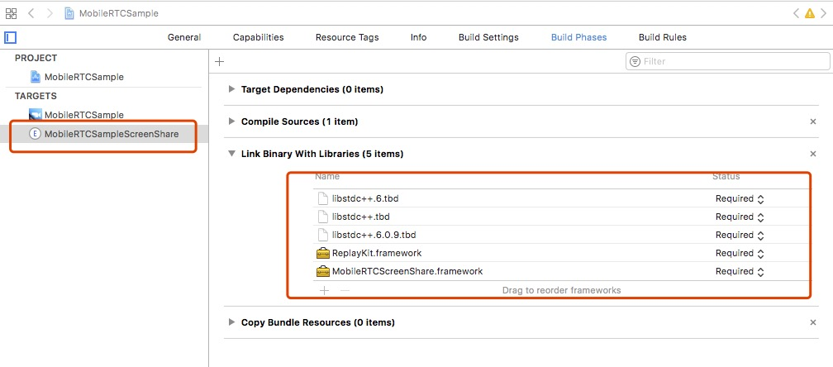
2. Response to Delegate & Present App Screen Share Usage Guide